Internship Project Report
Project Title: TravelGuideAI – Custom Itineraries for Your Next Journey
Submitted in partial fulfilment of the requirements for the
Google Cloud Generative AI
conducted by

SmartBridge

Submitted by

Team Leader: Varada Surya Kiran

Team member: Kopparthi Halini Sri Sai Durga Sirija

Team member: Lakshmisai Maddala

Team member: Leela Krishna Yatam

Team ID: LTVIP2026TMIDS63991
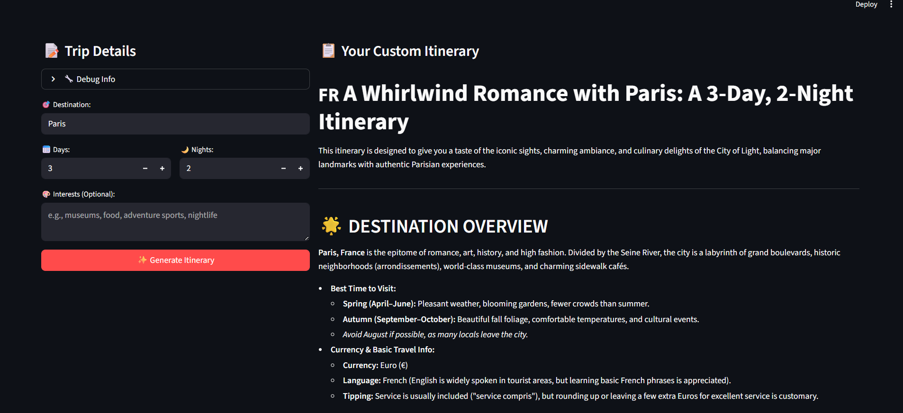
- INTRODUCTION

1.1 Project Overview
TravelGuideAI is an advanced AI-powered travel itinerary generator developed to simplify and automate the complex process of travel planning. Planning a trip often requires significant time and effort to research destinations, identify attractions, organize schedules, and match plans with personal preferences. TravelGuideAI addresses these challenges by providing a smart, efficient, and user-friendly solution.
The application is designed to be accessible, efficient, and scalable, making it suitable for both casual travelers and professional travel planners.

1.2 Purpose
The primary purpose of TravelGuideAI is to enhance and streamline the travel planning process by leveraging artificial intelligence. The key objectives of the system include:
- Reducing time spent on travel research: Users no longer need to browse multiple websites to gather information about destinations, attractions, and schedules.
- Providing personalized travel recommendations: The system generates itineraries tailored specifically to individual preferences, travel style, and duration.
- Automating itinerary creation using AI: By utilizing advanced language models, TravelGuideAI eliminates manual planning efforts and delivers instant, structured travel plans.
2. IDEATION PHASE
2.1 Problem Statement
Planning travel itineraries manually is time-consuming, requires extensive research, and often leads to incomplete or poorly structured plans. Travelers struggle to gather information about attractions, accommodations, and transportation efficiently.
2.2 Empathy Map Canvas
User Thinks:
- “I want a quick and personalized travel plan.”
User Feels:
- Confused due to too many online resources
User Says:
- “Travel planning takes too much time.”
User Does:
- Searches multiple websites for travel details
2.3 Brainstorming
Ideas considered:
- AI-based travel recommendation system
- Automated itinerary generator
- Travel chat assistant
- Personalized travel planner
3. REQUIREMENT ANALYSIS
3.1 Customer Journey Map
- User enters travel destination
- User selects trip duration
- User provides preferences
- System generates itinerary
- User downloads itinerary
3.2 Solution Requirement
Functional Requirements:
- Accept travel inputs
- Generate AI itinerary
- Provide travel recommendations
- Allow itinerary download
Non-Functional Requirements:
- Fast response time
- User-friendly interface
- Secure API integration
3.3 Data Flow Diagram (DFD)
Input → Processing → Output
User Inputs → Gemini AI Processing → Generated Itinerary
3.4 Technology Stack
Programming Language – Python
Python is used as the core programming language for developing the system. It is chosen because of its simplicity, readability, and strong support for artificial intelligence, data processing, and API integration.
Web Framework – Streamlit
Streamlit is used to build the user interface of the application. It allows developers to quickly create interactive web applications using simple Python code without requiring knowledge of HTML, CSS, or JavaScript.

AI Model – Google Gemini 1.5 Flash
Google Gemini 1.5 Flash is used as the core artificial intelligence model in the system. It provides fast and accurate responses for tasks such as text understanding, content generation, and analysis, making it suitable for real-time AI applications.

API Integration – Google Generative AI API
The Google Generative AI API is used to connect the application with the Gemini AI model. It enables seamless communication between the system and the AI service

Environment Management – python-dotenv
python-dotenv is used to manage environment variables securely. It helps store sensitive data such as API keys and configuration settings in a separate file,
4. PROJECT DESIGN
4.1 Problem Solution Fit
TravelGuideAI effectively solves the problem of manual travel planning by automating itinerary creation using AI.
4.2 Proposed Solution
A web application where users input:
- Destination
- Duration
- Preferences
The system generates:
- Day-wise itinerary
- Dining recommendations
- Accommodation suggestions
- Travel tips
4.3 Solution Architecture
User Interface (Streamlit) → API Integration → Gemini AI Model → Generated Itinerary Output
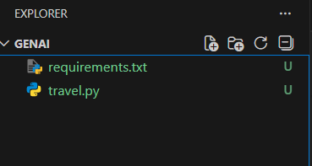
5. PROJECT PLANNING & SCHEDULING

5.1 Project Planning
Ideation – 1 Week
In this phase, the project idea was planned and defined. Requirements were gathered, objectives were set, and the overall system design and workflow were outlined.

Development – 2 Weeks
During this phase, the actual implementation of the system was carried out. The application was developed using Python, Streamlit, and AI integration, and core functionalities were built.

Testing – 1 Week
In the testing phase, the system was checked for errors, bugs, and performance issues. Different test cases were executed to ensure the application works correctly and reliably.

Documentation – 1 Week
This phase involved preparing project documentation, including reports, technical details, user guides, and explanations of the system’s features and workflow.

6. FUNCTIONAL AND PERFORMANCE TESTING
6.1 Performance Testing
- System responds within seconds
- Handles multiple inputs efficiently
- Accurate AI-generated itineraries
Travel.py Code:
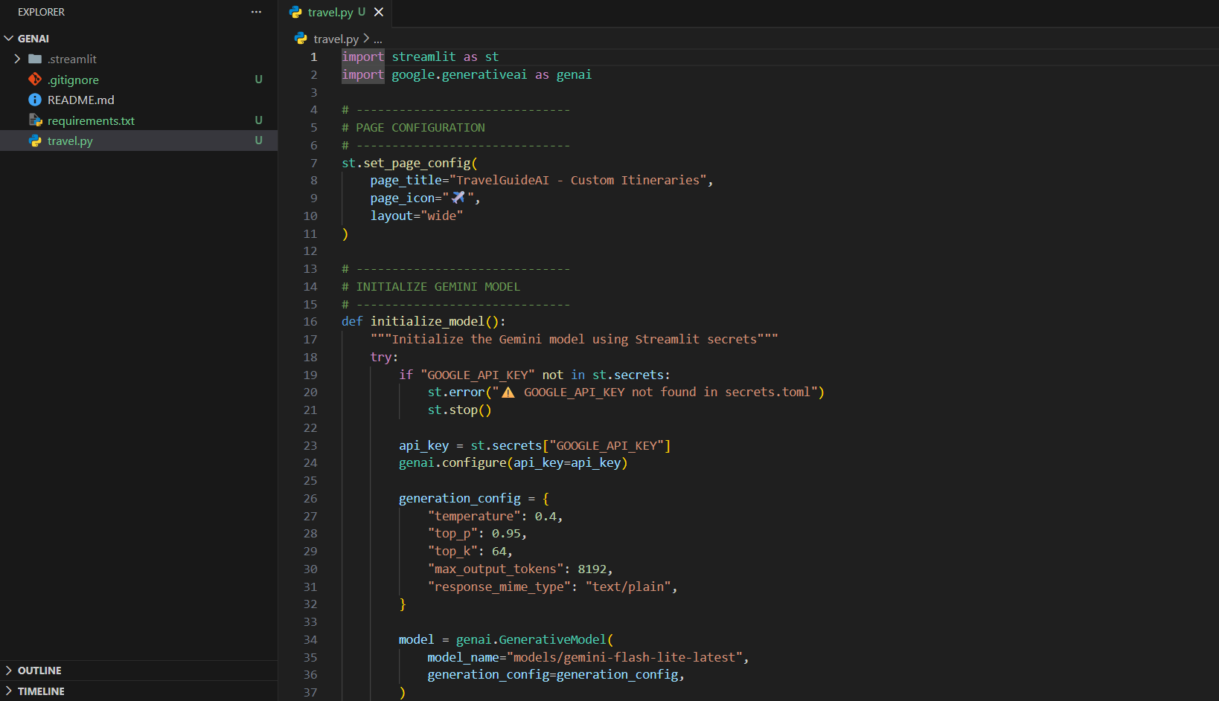
Requirements.txt:
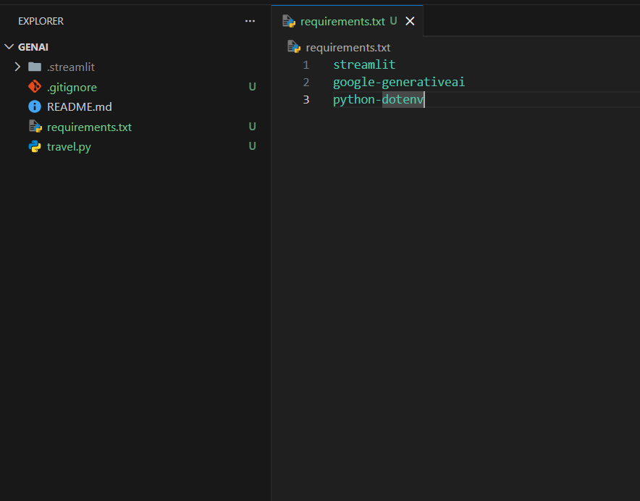
Running the Application:
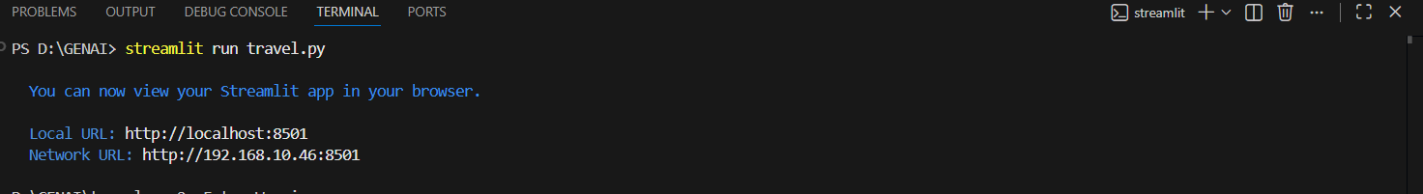
User Interface:
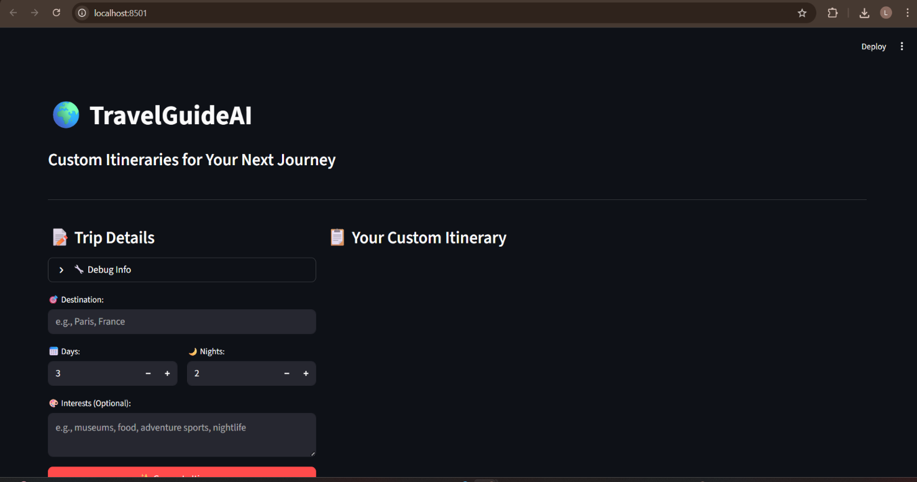
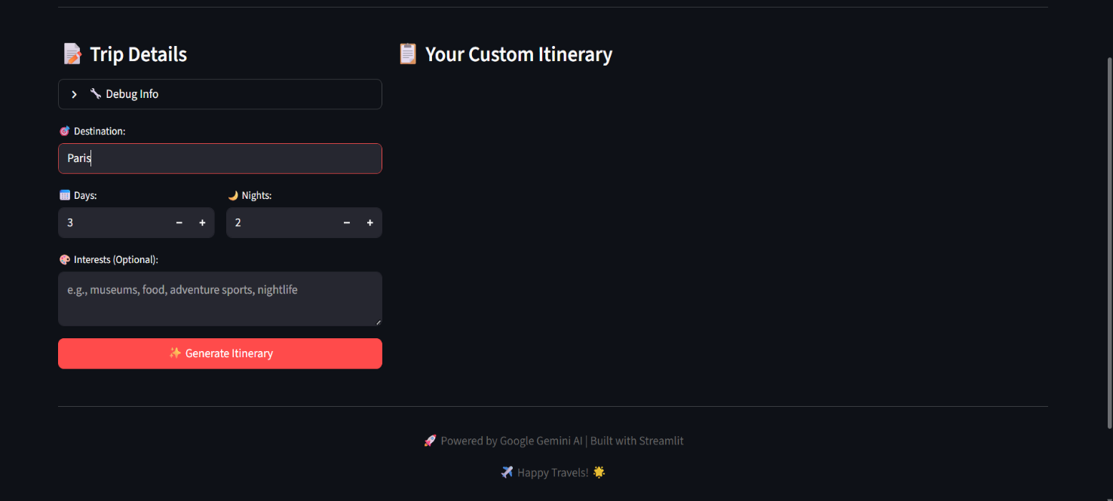
7. RESULTS
7.1 Output Screenshots
Include screenshots of:
User input form:
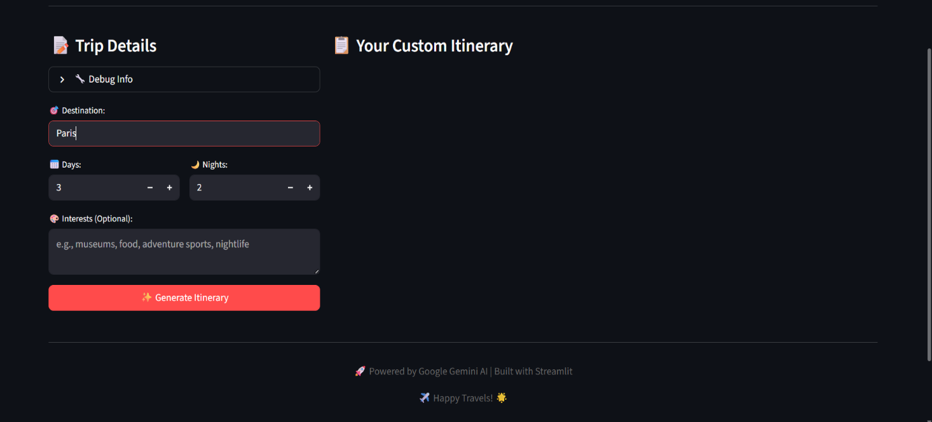
Generated itinerary:
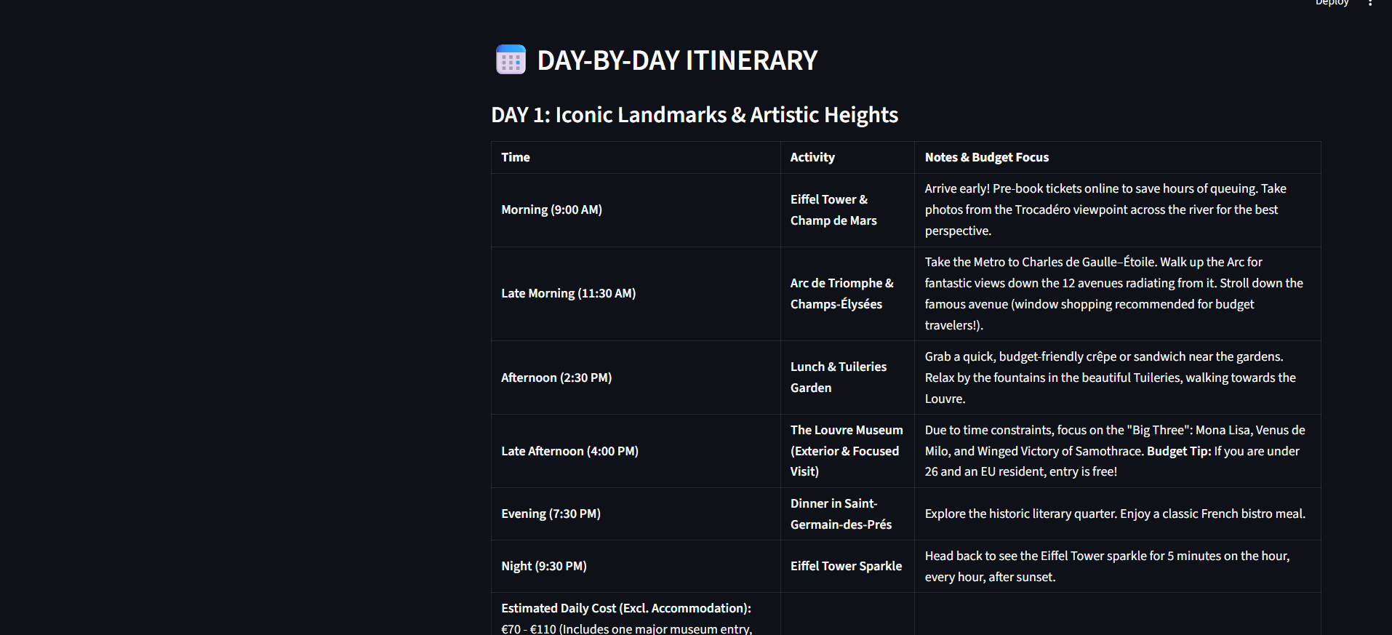
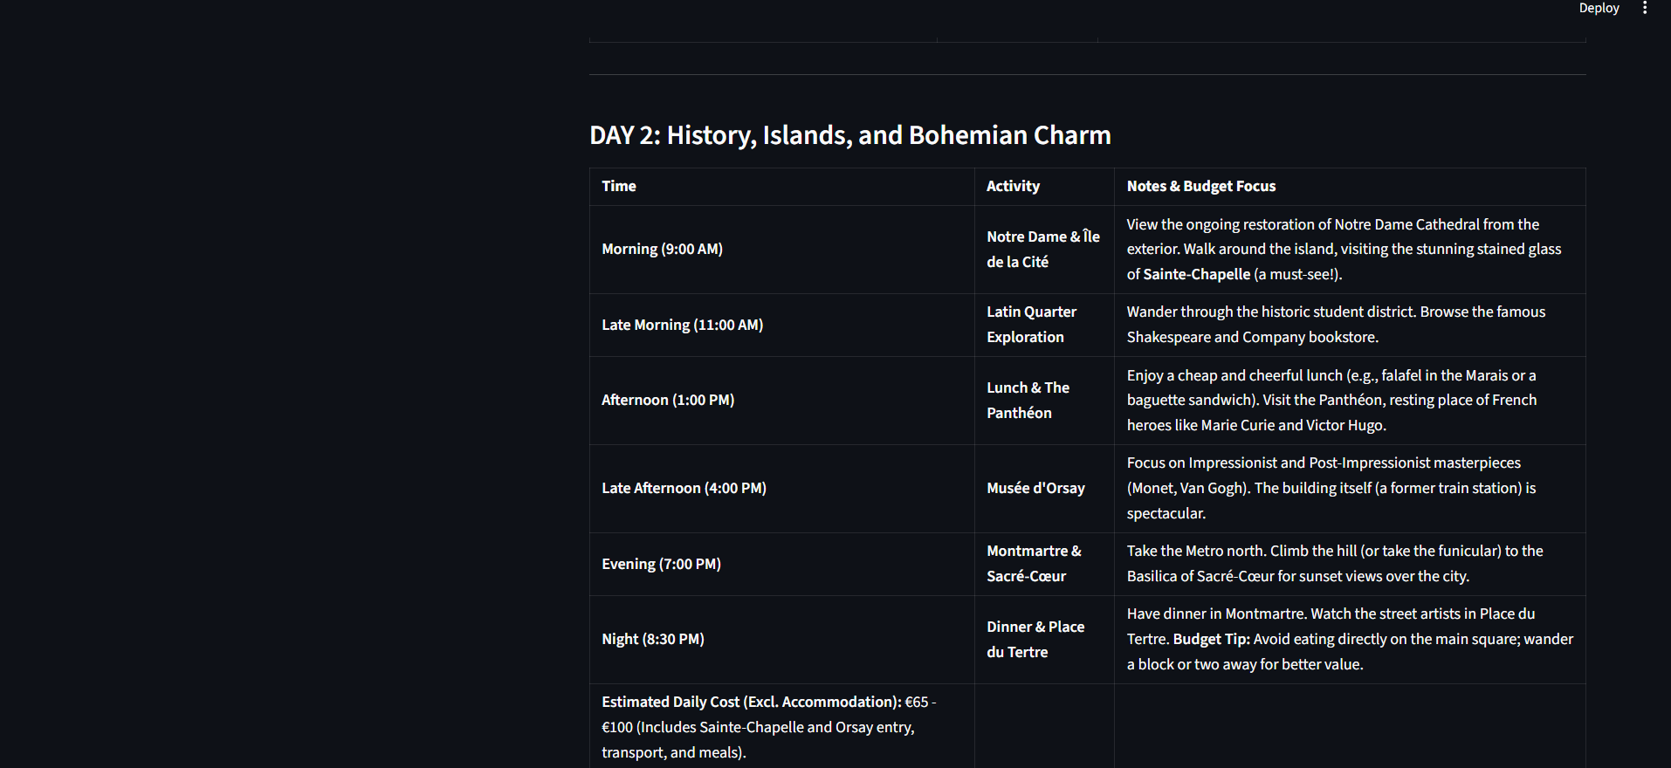
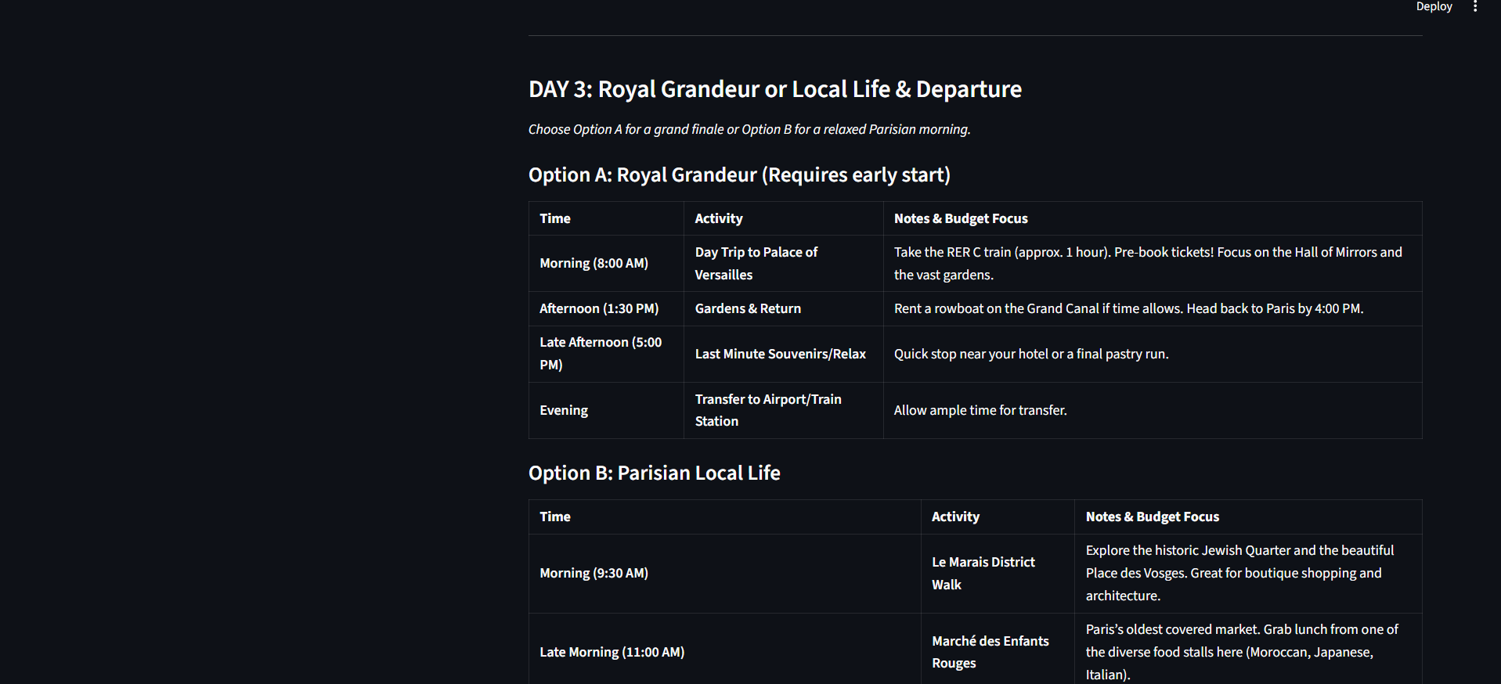
Download feature:

8. ADVANTAGES & DISADVANTAGES
Advantages
• Saves travel planning time – The system quickly generates travel plans, reducing the time users spend searching for information manually.
• Personalized recommendations – It provides customized suggestions based on user preferences such as budget, location, and interests.
• Easy to use – The simple and user-friendly interface allows users to operate the application without technical knowledge.
• AI-powered automation – The use of artificial intelligence automates itinerary creation, making the process faster and more efficient.

Disadvantages
• Requires internet connection – The application depends on an active internet connection to access AI services and APIs.
• Depends on API availability – The system’s performance relies on external AI APIs, so downtime or limits can affect functionality.
9. CONCLUSION

TravelGuideAI successfully demonstrates how artificial intelligence can transform and simplify the process of travel planning. The system shows the practical application of modern AI technologies in solving real-world problems by automatically generating personalized travel itineraries based on user preferences.
By integrating advanced AI models, the application is able to understand user inputs, analyze requirements, and provide structured, relevant, and well-organized travel plans within seconds. This significantly reduces the time and effort traditionally required for manual travel planning.
The platform enhances user convenience by offering intelligent suggestions, improving decision-making, and delivering a smooth and interactive user experience.
It highlights how AI-powered solutions can increase efficiency, accuracy, and accessibility in everyday activities such as trip planning. Overall, the project proves that AI can play a major role in building smart, user-friendly digital assistants for travel and tourism.
However, the system also has certain limitations. It requires a stable internet connection to function effectively, as it depends on real-time communication with AI services.
Additionally, the application relies on external APIs, meaning its performance is affected by API availability, response speed, and usage limits. Despite these constraints, TravelGuideAI remains a valuable and innovative solution for modern travel planning needs.

10. FUTURE SCOPE
- Budget-based recommendations
- Hotel booking integration
- Maps integration
- Multi-language support
- Mobile app version

11. APPENDIX
Github Link: https://github.com/LeelaKrishnaYatam/GENAI

Demo Video Link:
https://drive.google.com/file/d/1sO0ghSAtUQvHZx3veEh2J1jvcmk08Lm/view?usp=drive_link

